WEEK 2 – POWER BI DATA ANALYSIS
Superstore Sales & Profit Analysis Dashboard

1.INTRODUCTION:
Power BI is a business intelligence and data visualization tool used to transform raw data into meaningful insights. In this project, the Superstore Sales Dataset is analyzed using Microsoft Power BI. The data is prepared, organized, and modeled for effective analysis. DAX measures are created to calculate important business metrics such as total sales, total profit, total orders, total quantity, average sales, and profit margin. Different visualizations such as KPI cards, charts, slicers, and a decomposition tree are used to create an interactive dashboard. The final dashboard helps users understand sales and profit performance clearly and supports better data-driven analysis.

2.OBJECTIVES:
- To import and analyze the Superstore Sales Dataset using Power BI.
- To prepare and organize the data for analysis.
- To create calculated measures using DAX.
- To analyze sales and profit performance.
- To compare sales across different categories and regions.
- To identify sales trends over time.
- To create an interactive and user-friendly dashboard.
- To obtain meaningful insights from the dataset.

3.DATASET DESCRIPTION:
The Superstore Sales Dataset contains information about customer orders, products, sales, quantity, profit, regions, categories, and order dates. It provides useful information for analyzing business performance and identifying sales and profit patterns. The dataset contains important fields such as Order Date, Ship Date, Customer ID, Customer Name, Product ID, Product Name, Category, Sub-Category, Sales, Quantity, Profit, Region, and Segment.
Important Columns
- Order Date – Date on which the order was placed
- Customer ID – Unique identification of customers
- Product ID – Unique identification of products
- Category – Product category
- Sub-Category – Product sub-category
- Sales – Sales amount
- Quantity – Number of products ordered
- Profit – Profit earned from sales
- Region – Geographical region
- Segment – Customer segment

4.DATA PREPARATION:
The Superstore Sales Dataset was imported into Microsoft Power BI for analysis. The data was reviewed and organized to ensure that the required fields were available for analysis. A separate Date Table was created to perform time-based analysis. Customer, Product, and Region tables were also created to organize the data model. Relationships were established between the tables and the main Superstore dataset. The prepared data was then used to create DAX measures and interactive visualizations.

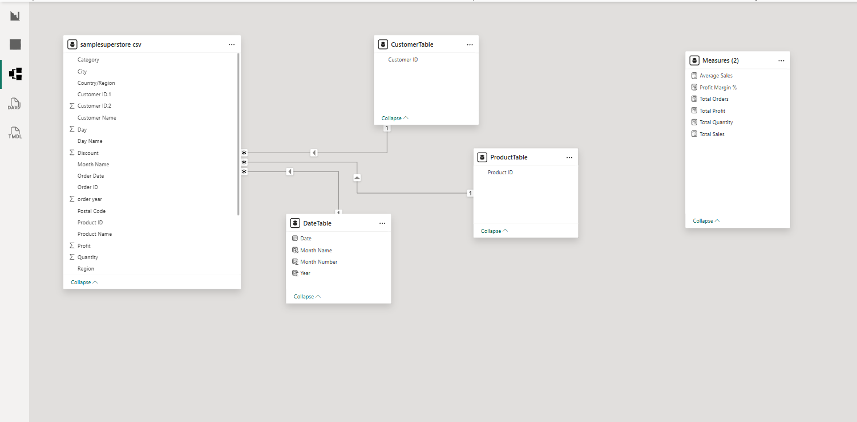

Power BI Data Model and Relationships

5.DATE TABLE:
A separate Date Table was created in Power BI to perform time-based analysis. The Date Table contains Date, Year, Month Name, and Month Number columns. It was connected with the Order Date column of the Superstore dataset. This table helps in analyzing sales trends across different dates and years.

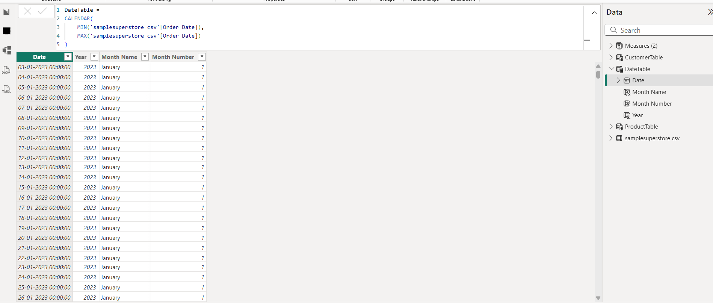
Date Table Created in Power BI

6.DAX MEASURES:
DAX (Data Analysis Expressions) measures were created in Power BI to calculate important business metrics from the Superstore dataset. These measures help in analyzing sales, profit, orders, quantity, average sales, and profit margin.
📌 Measures Created
Total Sales
Total Profit
Total Orders
Total Quantity
Average Sales
Profit Margin %

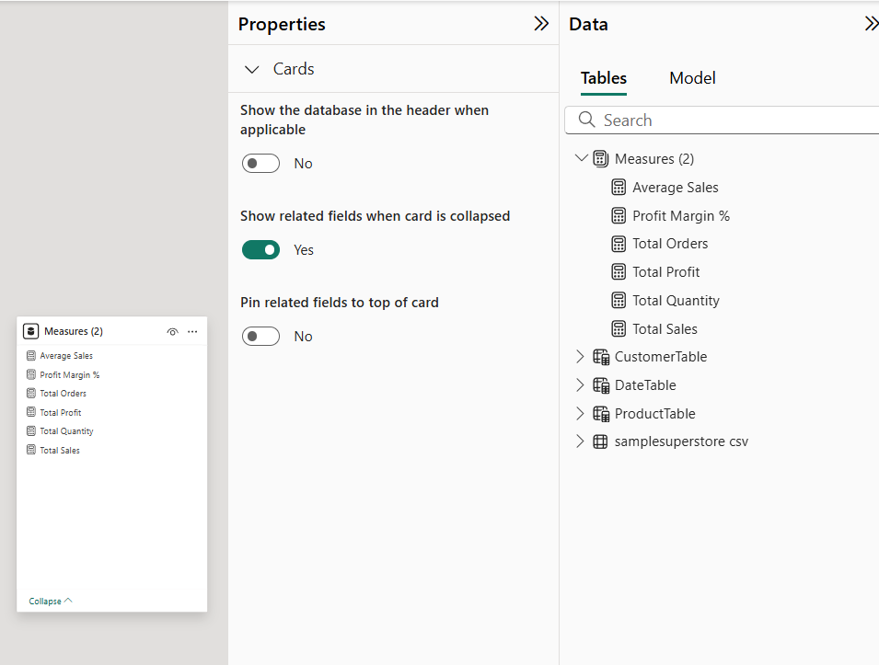
DAX Measures Created in Power BI

7.DASHBOARD COMPONENTS:
The Superstore Sales & Profit Analysis Dashboard was created using different Power BI visualizations and interactive components. The dashboard includes KPI cards, charts, slicers, and a decomposition tree. These components help to analyze sales, profit, orders, quantity, and sales trends in an interactive and easy-to-understand manner.
7.1 KPI Cards
Six KPI cards were created to display Total Sales, Total Profit, Total Orders, Total Quantity, Average Sales, and Profit Margin %.
7.2 Category-wise Sales
A clustered column chart was used to compare sales across different product categories.
7.3 Region-wise Profit
A clustered column chart was used to compare profit across different regions.
7.4 Sales Over Time
A line chart was used to identify sales trends over time.
7.5 Slicers
Slicers were added for Year, Category, Region, and Segment to enable interactive filtering of the dashboard.
7.6 Decomposition Tree
A decomposition tree was used to analyze Total Sales and understand its breakdown by Category.

8.DASHBOARD:
The final dashboard provides an interactive view of the Superstore sales and profit performance. It combines KPI cards, charts, slicers, and a decomposition tree in a single dashboard. This helps users quickly understand important business metrics and explore the data using different filters.

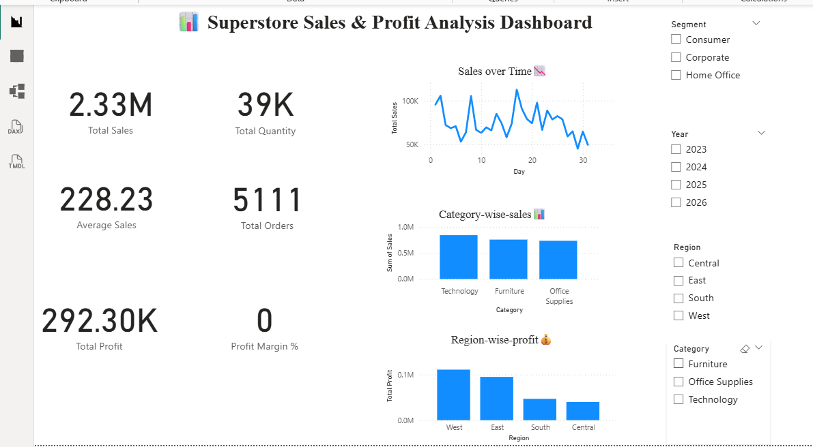
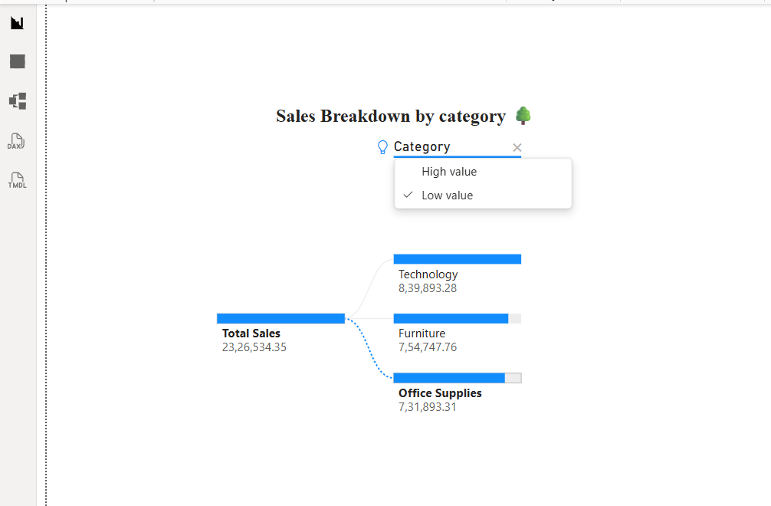

The dashboard provides an interactive overview of sales and profit performance using KPI cards, charts, slicers, and a decomposition tree.

9.KEY INSIGHTS:
- Sales Performance: KPI cards help to monitor the overall sales performance quickly.
- Profit Analysis: Total Profit and Profit Margin % help to understand the profitability of the business.
- Category Analysis: Category-wise Sales helps to compare the sales performance of different product categories.
- Regional Analysis: Region-wise Profit helps to identify differences in profitability across regions.
- Time Analysis: Sales Over Time shows the sales trend across different dates.
- Interactive Filtering: Slicers allow users to filter the dashboard by Year, Category, Region, and Segment.
- Sales Breakdown: The Decomposition Tree helps to explore the factors contributing to Total Sales.

10.ADVANTAGES:
- Interactive Analysis – Users can explore the data interactively.
- Easy Visualization – Charts and KPI cards make complex data easy to understand.
- Performance Comparison – Sales and profit can be compared across categories and regions.
- Dynamic Filtering – Slicers allow users to filter the dashboard based on Year, Category, Region, and Segment.
- Quick Decision Making – KPI cards and visualizations provide important business information at a glance.

11.CONCLUSION:
The Superstore Sales Dataset was successfully analyzed using Microsoft Power BI. The data was organized and modeled, and DAX measures were created to calculate important business metrics. Various visualizations such as KPI cards, charts, slicers, and a decomposition tree were used to develop an interactive dashboard. The dashboard provides a clear view of sales and profit performance and helps users understand the data easily. Overall, this project demonstrates how Power BI can be used to transform raw data into meaningful and interactive business insights.

12.TOOLS & TECHNOLOGIES:
- Tool Used: Microsoft Power BI
- Data Preparation: Power Query
- Data Modeling: Relationships and Data Tables
- Data Analysis: DAX Measures
- Data Visualization: KPI Cards, Charts, Slicers and Decomposition Tree
- Dataset: Superstore Sales Dataset

